Mediator reference Guide

Justice of the Peace Court meDEation system

Table of Contents
Registering and Logging in to the System 4
System Dashboard 7
Using Conversations 9
Completing the Stipulated Agreement 10
Submitting the Stipulated Agreement to the Court 20
Completing the Mediation Report 20
Appendices 21
Stipulated Agreement Example (double click to open full document) 21
Mediation Report Form 22
Contact Information 23
Changing Notification and Password Settings 23

Registering and Logging in to the System

When a system administrator adds a user to the system, the user will receive an email similar to the one below instructing the user to log in and create a personal password.

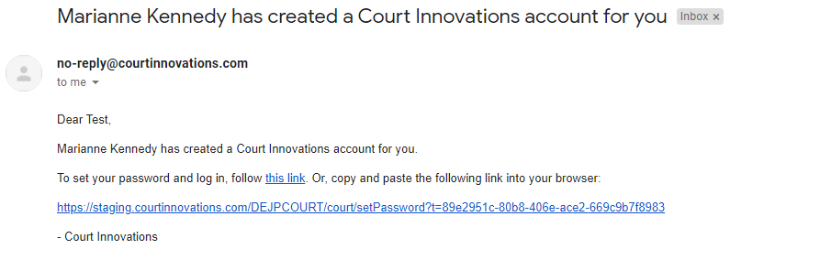

Upon clicking the link in the email, the user will be directed to the portal to create a new system password. Please note, the password is required to have at least one capital letter, one lower case letter and a number or special character and be at least 8 characters long.

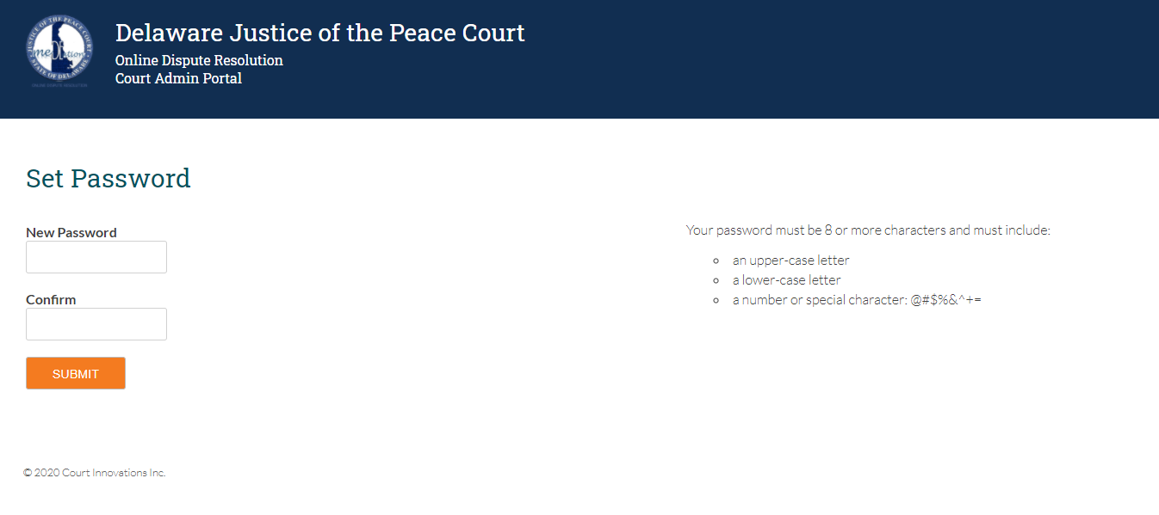

Once the user inputs the desired password and clicks SUBMIT, the user will be directed to the screen below to confirm that the password was accepted. This screen will also be displayed anytime the user clicks the login link in the top right-hand corner of the home screen. Please note, there is also a link to reset your password if it has been forgotten.
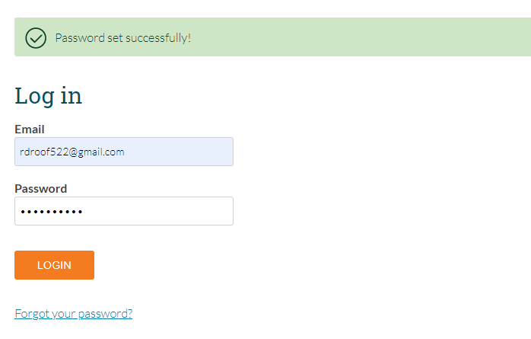

System Dashboard

Once a user logs in to the system, the user will be brought to the system dashboard. From this screen, the user receives a snapshot view of the cases assigned to them in the system. Users will have two distinct categories with an indicator showing how many cases are in each status. The categories are:
- In Progress: Mediator
- Indicate Outcome
Cases in “In Progress: Mediator” status are those cases that the user is actively involved with in mediation.
Cases in the “Indicate Outcome” status are awaiting administrative action to complete them in the ODR system. There is no action needed on the User’s part for any cases in this status.
For the user to view the case detail for the cases assigned to them, the user should click on the LANDLORD TENANT header circled in red below.

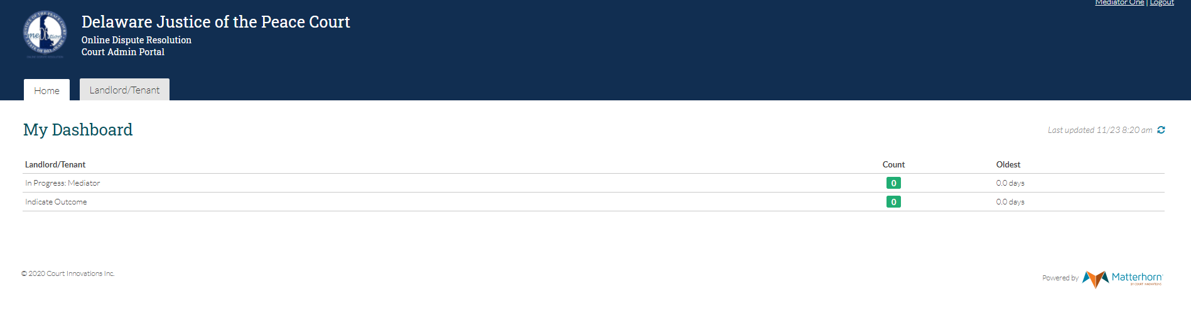

Users can search for cases from the Case Display screen by clicking the status along the top of the screen (circled in red), entering the desired case information (Civil Action Number, Party Name, Court location) or by clicking the header above each column and sorting the data in ascending or descending order. Users will select the desired case by hovering their cursor over the line and left clicking.

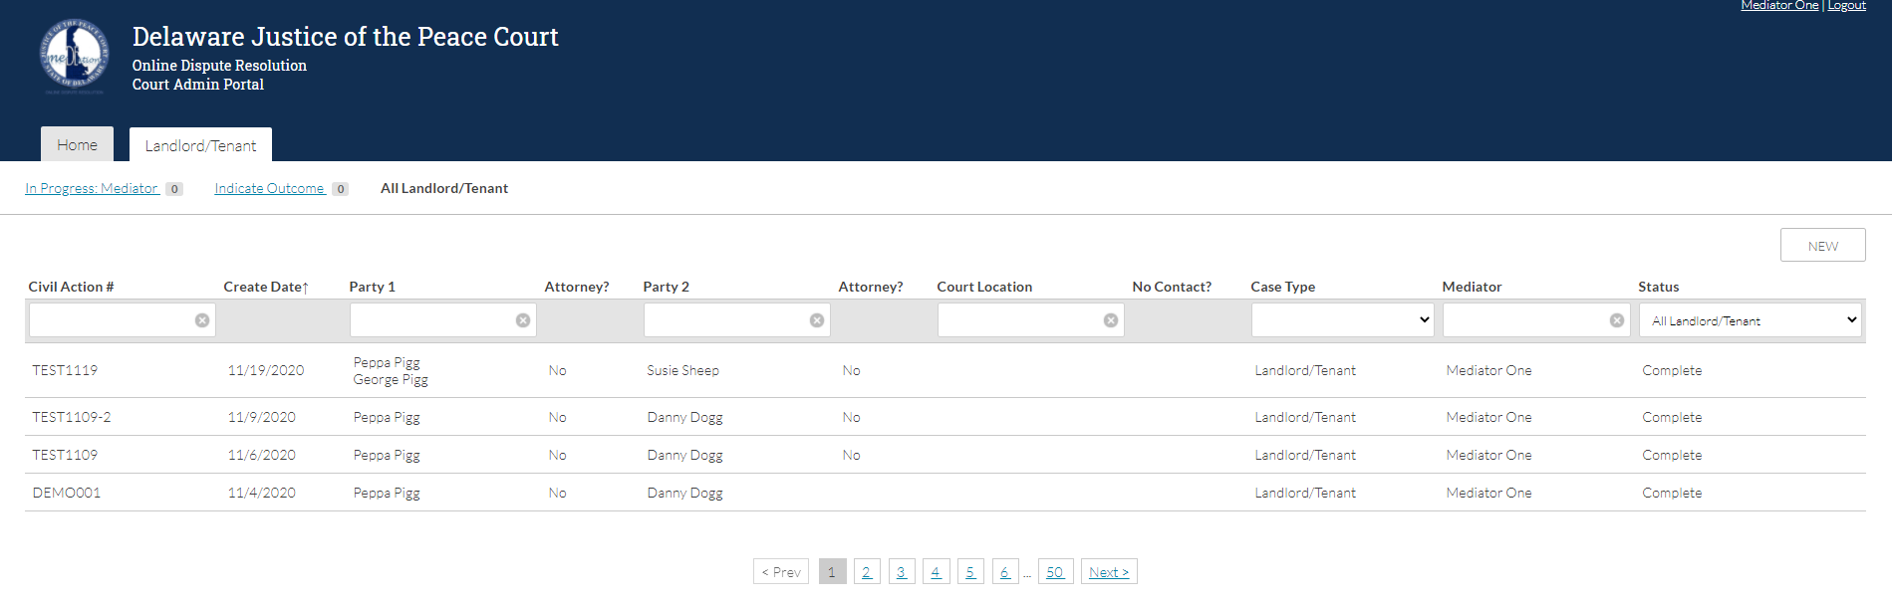

Using Conversations

Users can send messages through the conversations tab. There are conversation channels that allow for conversations between all parties, each party and the mediator privately and court staff and the mediator that the parties will not have access to. To send a message, users will type their message in the box and click send. Users also have the ability to attach files to the conversation. Mediators have the ability to create a Zoom Meeting for live chat conversations with one or more of the parties.

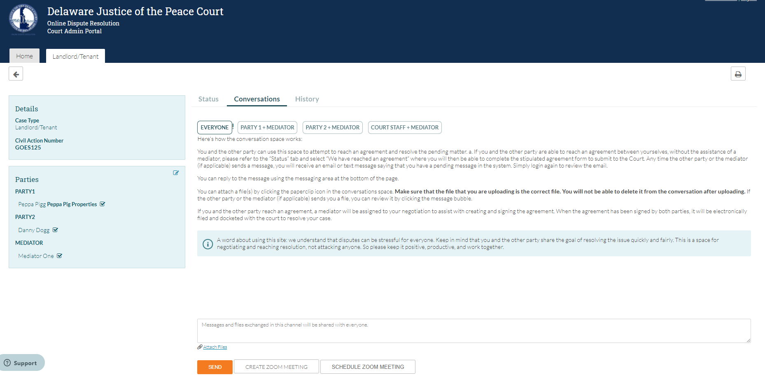

Completing the Stipulated Agreement

If an agreement is reached, the user will utilize the embedded form generator in the system to draft the Stipulated Agreement. From the case detail screen, the user will click the button for PREPARE AGREEMENT which will open another section on the same page where the user will click the button for Stipulated Agreement and begin to input the appropriate data into the provided fields. When all of the appropriate information is complete, the user will click the STIPULATED AGREEMENT button at the bottom of the form generator to submit the form to the system.

Please see next pages for a visual aid of the screens.
.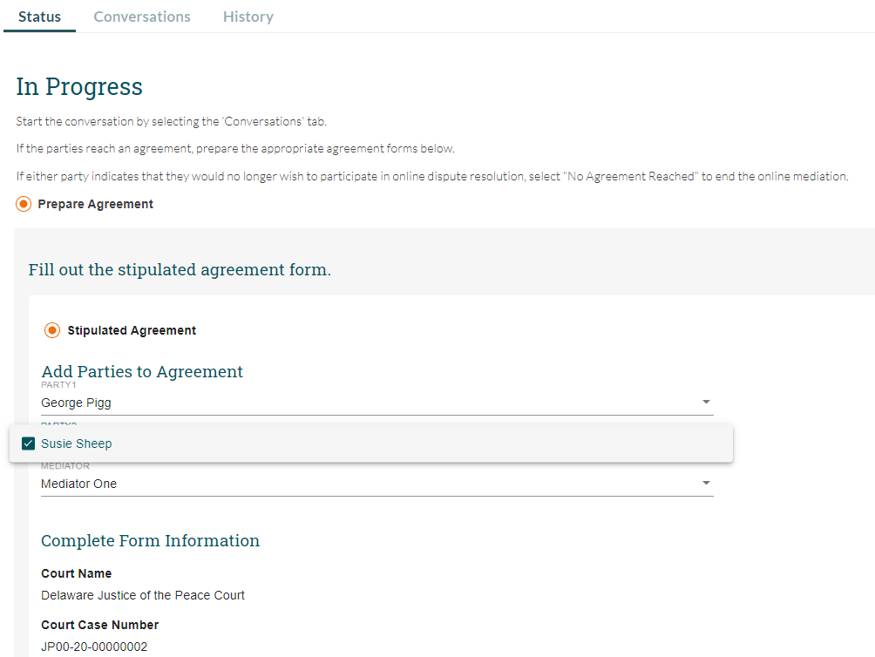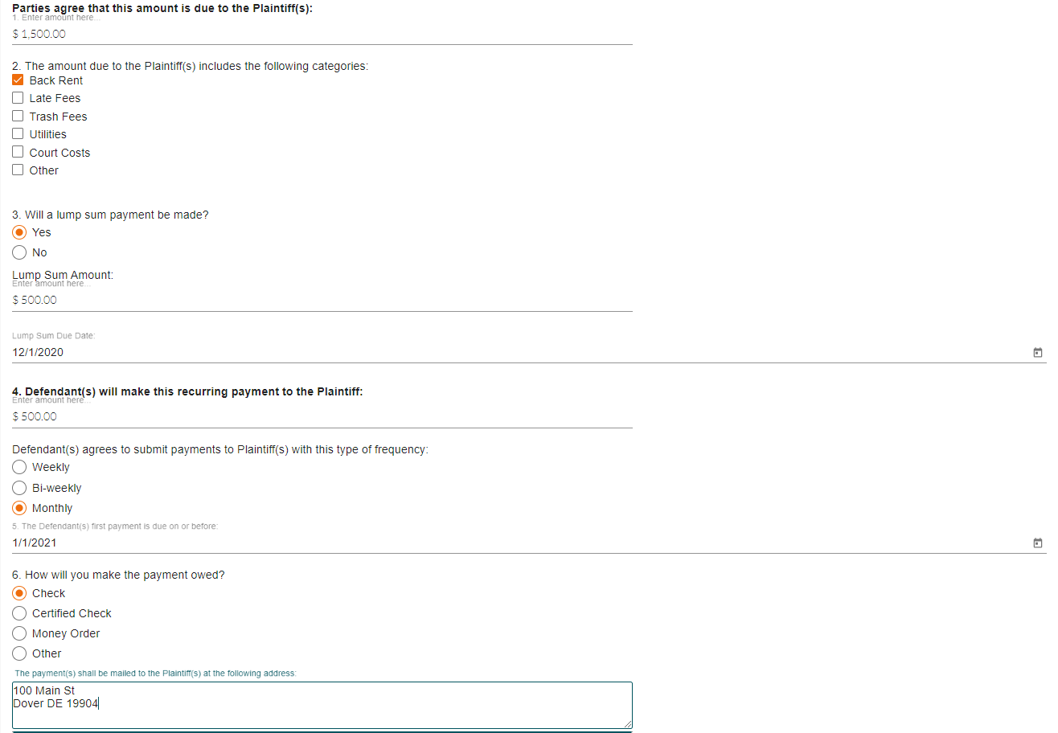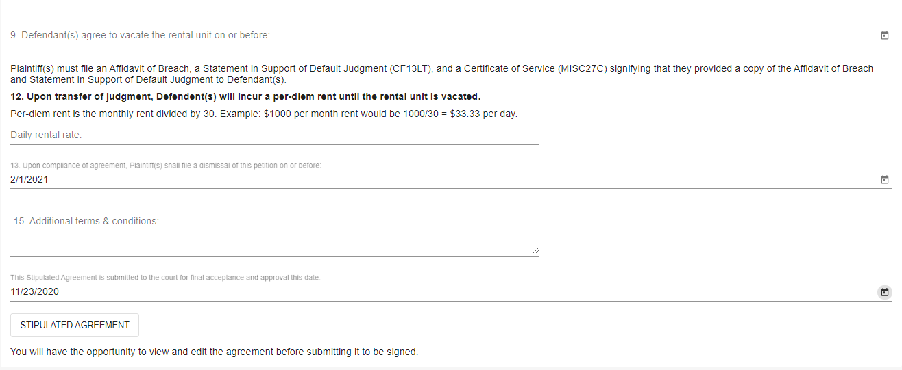

Once the form is submitted to the system, the user will have an opportunity to review and edit any information that was entered in the form generator. If all the information appears correctly, the user will click the SAVE & SUBMIT FORM button to send the form to all involved parties for review and signature.

Please see next pages for a visual aid of the screens.

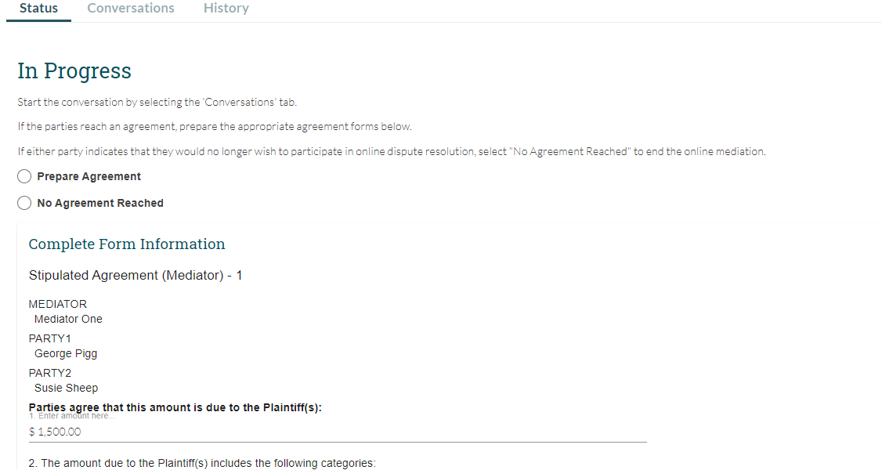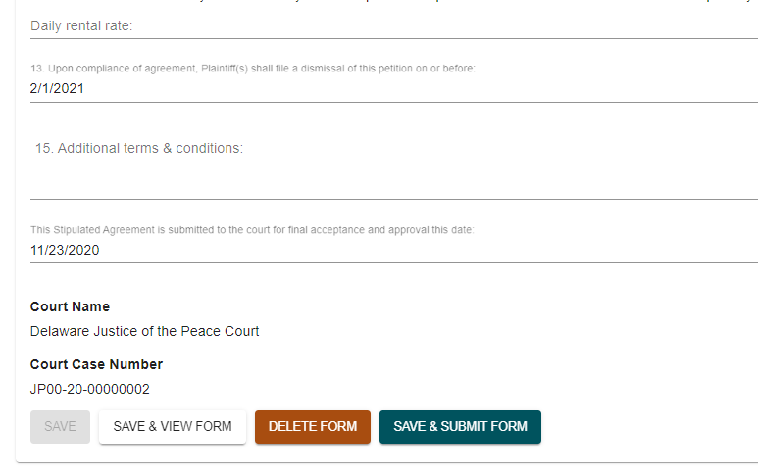

Once the user is notified that all associated parties have reviewed and signed the Stipulated Agreement, the user will review and sign the form to finalize and submit the form to the court for docketing. Note: If a party rejects the agreement, the party will have to indicate the reason for the rejection. Once the party submits the rejection, the mediator will have the ability to make edits and resubmit the agreement to all parties.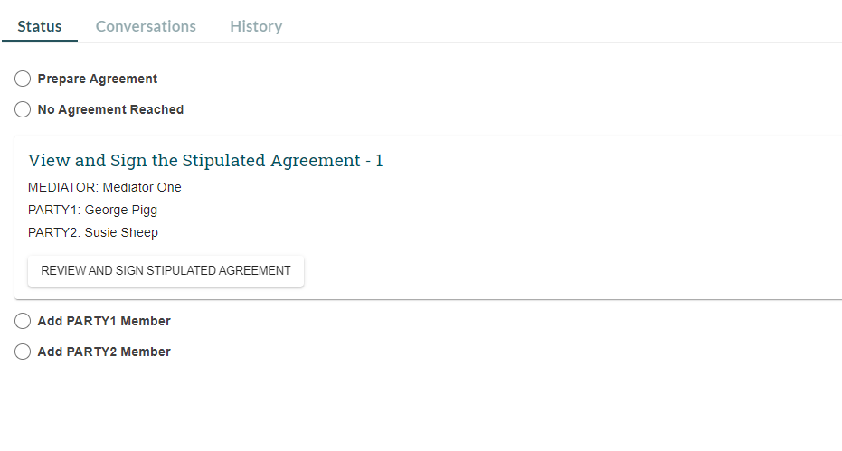

The user will be able to review the agreement and confirm that all necessary signatures are present before the user signs the agreement. Please note that the mediator will be the last signature affixed to the agreement.

Please see next page for a visual aid of the screens.

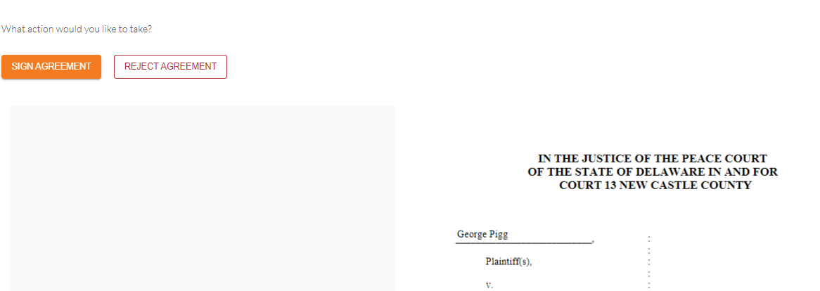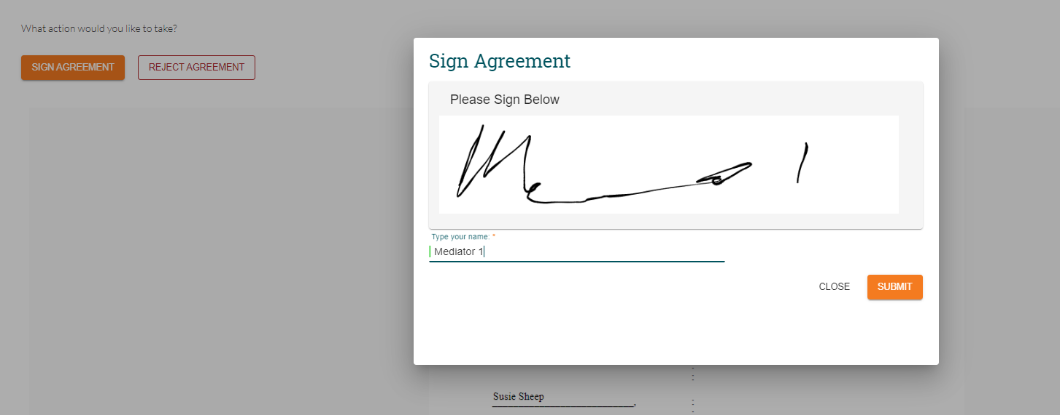

Submitting the Stipulated Agreement to the Court

Once all signatures have been affixed to the agreement, the user will click the button for PARTIES REACHED AN AGREEMENT and enter the generic court email address along any additional emails. The user will click the drop-down arrow and select the Stipulated Agreement form and click SUBMIT in order to send the completed form to the court for docketing.

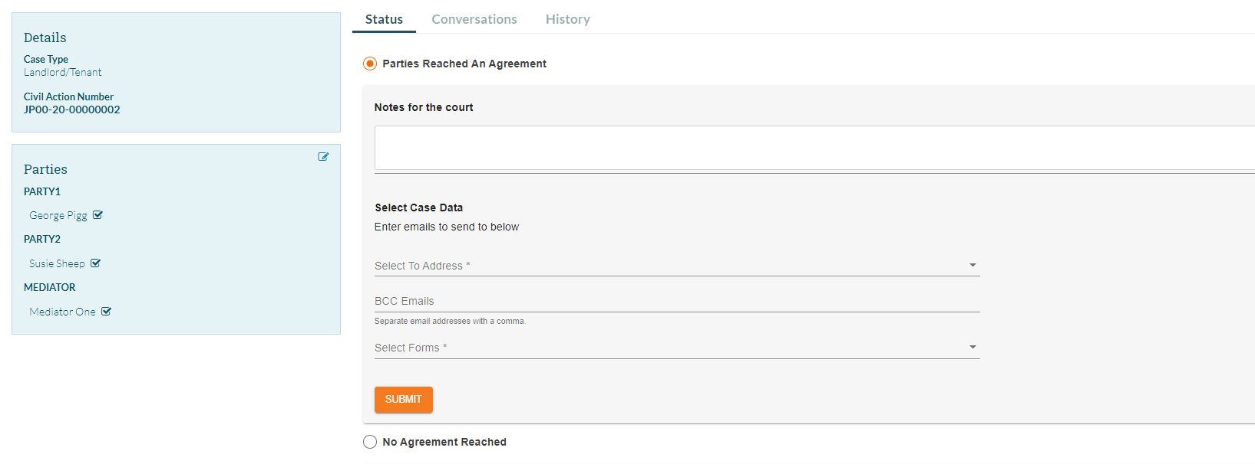

Completing the Mediation Report

Appendices

Stipulated Agreement Example (double click to open full document)

Mediation Report Form

Contact Information

Phone Number 302-674-7090
Email address jpmedeation@delaware.gov
Website https://courts.delaware.gov/jpcourt

Mediator Assistance jpmedeationmediator@delaware.gov

Changing Notification and Password Settings

Users change the frequency of emails they receive from the system by changing the notification settings. This is accessed by clicking the username in the top right-hand corner of any ODR system screen

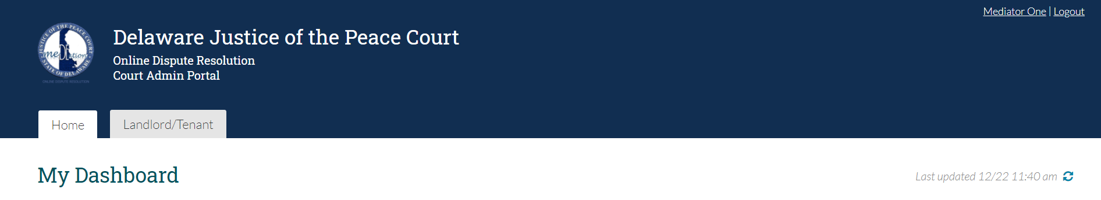

On the MY ACCOUNT screen, users can click the + to the right of MANAGE NOTIFICATIONS and CHANGE PASSWORD to adjust the frequency of emails they receive from the system. They can also update their password by typing their current password and entering their new password twice.

